Figure1Red Cross War Memorial Children’s Hospital – Circa 1987

The artist Joy Collier depicted the right profile of the future development of the hospital

Figure 2.**PIONEERS OF PAEDIATRIC SURERY IN SOUTH AFRICA**

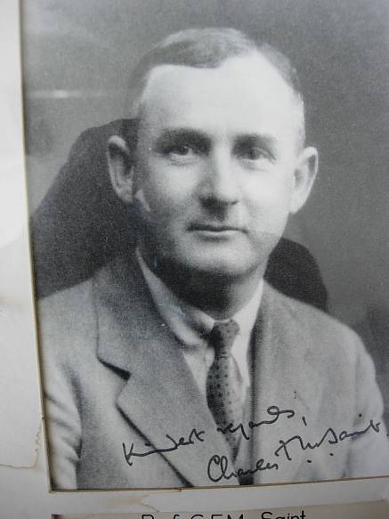

Prof Charles F M Saint, first Professor of Surgery, University of Cape Town 1920-1946

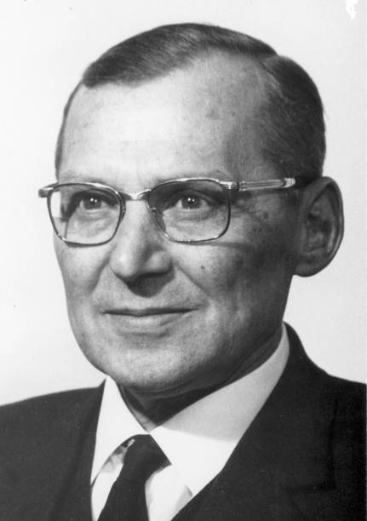

Prof. JH LOUW , the Father of Pediatric Surgery in South Africa, Prof. of Surgery at the University of Cape Town 1955- 1980 and Head of Surgery at the Red Cross War Memorial Children’s Hospital 1955-1975.

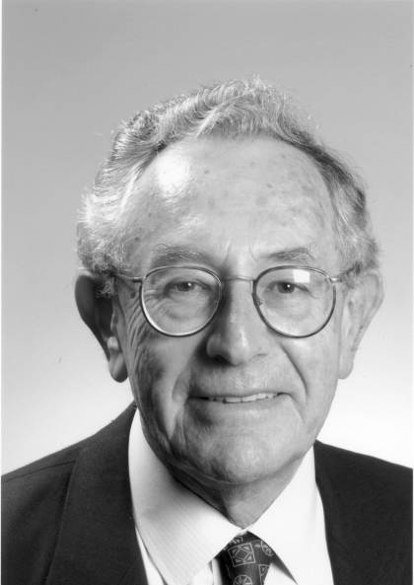

Prof. Sydney Cywes, First Charles F. M. Saint Professor of Pediatric Surgery, University of Cape Town 1975-1996 .