Figure 1.
A.  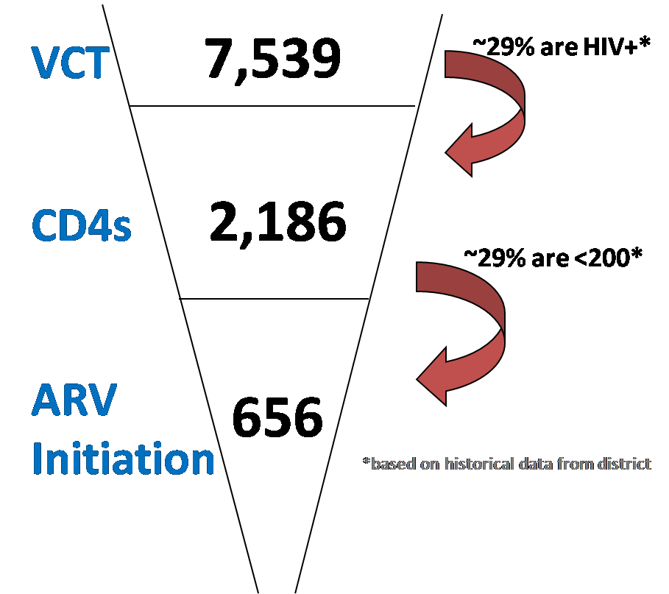 | B.
  Site | headcount % | Need HAART | Need CD4 count test | Need HIV test
  PHC 1 | 2.1% | 14 | 46 | 159
  PHC 2 | 4.2% | 28 | 92 | 318
  PHC 3 | 4.4% | 29 | 96 | 331
  PHC 4 | 3.8% | 25 | 82 | 283
  PHC 5 | 3.3% | 21 | 72 | 247
  PHC 6 | 4.9% | 32 | 106 | 366
  PHC 7 | 5.2% | 34 | 114 | 394
  PHC 8 | 5.9% | 39 | 129 | 446
  PHC 9 | 1.1% | 7 | 24 | 81
  PHC 10 | 6.7% | 44 | 147 | 505
  PHC 11 | 6.9% | 45 | 150 | 519
  PHC 12 | 7.1% | 46 | 154 | 532
  PHC 13 | 0.9% | 6 | 19 | 67
  PHC 14 | 3.1% | 20 | 67 | 231
  PHC 15 | 4.3% | 28 | 94 | 323
  PHC 16 | 7.3% | 48 | 159 | 547
  PHC 17 | 9.7% | 63 | 211 | 728
  PHC 18 | 9.7% | 64 | 213 | 734
  PHC 19 | 1.5% | 10 | 33 | 113
  PHC 20 | 8.2% | 53 | 178 | 615
  Total | 100% | 656 | 2186 | 7539

Legend for Figure 1A: Calculation of number of clients that will need HIV and CD4 count testing in a District with 20 PHCs, in which an estimated 656 new HAART initiations are required each month.

Legend for Figure 1B: Facility level HIV and CD4 test estimates derived from "District HIV Target Calculator" (www.ihi.org) for a District that initiates 656 new clients on HAART each month, where HIV prevalence for the population is 29% and 30% of HIV positive clients have a CD4 less than 200 cell/dl. Calculations for each health care site: "Headcount %" is from District access figures, "Need HAART" is (656 x "headcount %"), "Need CD4 count test" is ("Need HAART" ÷ 30%), "Need HIV test" is ("Need CD4" ÷ 29%).

Figure 2

Legend for Figure 2. Estimated number of new patients requiring HAART initiation in South Africa in 2010 (based on CD4 threshold of 200 cell/dl), 2011 (during transition to new threshold of 350 cells/dl), and 2012, assuming that the backlog of patients requiring HAART created by the new CD4 threshold recommendations (4) could be cleared in 2011.

